March 2024
Toole Design Group LLC
Appendix C: Review of Existing Plans and Policies

Review of Existing Plans and Policies
Recent planning efforts in Reedley established the provision of active transportation facilities as a major priority to support the well-being and quality of life of residents and visitors. These plans, as well as a multi-use trail prefeasibility study developed by a graduate student in cooperation with the City, provide a foundation that this current plan will build on. Critical takeaways from each plan and study, along with relevant goals, objectives, and policies, are detailed below.

City of Reedley Bicycle and Pedestrian Mobility Plan (2019)
This plan consolidates the recommendations from the 2010 City of Reedley Bicycle Transportation Plan with the 2018 Fresno County Regional Active Transportation Plan (ATP) and provides guidance for the long-term development of a bicycle and pedestrian network across the city. The plan also sets goals, objectives, and policies related to active transportation in Reedley. The plan builds on the Reedley chapter of the Fresno County Regional ATP by providing further detail on locations and costs for proposed bicycle and pedestrian projects and identifying potential funding sources. The Bicycle and Pedestrian Mobility Plan does not describe how proposed facilities were selected. The 2019 proposed network, which reflects previous City and County planning efforts, will be considered in the development of an updated proposed network as part of this current Active Transportation Plan.
Table 1: Relevant Goals, Objectives, and Policies from the City of Reedley Bicycle and Pedestrian Mobility Plan
Relevant Goals and Objectives
1. Provide safe, accessible, and continuous bicycle and pedestrian facilities as an integral component of a multi-modal transportation network.
- Continue development of a continuous bicycle and pedestrian network linking residential communities with schools, employment areas, shopping centers, and recreational activities.
- Maintain signage, striping, shoulders, lane clearances, and pathways on the existing bicycle and pedestrian transportation network.
- Provide bicycle and pedestrian support facilities, including bike racks, at popular destination areas and installed on transit vehicles.
2. Recognition of bicycling and walking as viable alternative modes of transportation that necessitates inclusion in local, regional, and state transportation planning efforts.
3. Promote bicycle and pedestrian safety through the education and enforcement of traffic laws.
- Develop and distribute the Reedley, Fresno County, and Tulare County Connectors Bikeway Map pamphlets that include information on bicycle and pedestrian safety and rules.
4. Advance the development of a continuous bicycle and pedestrian transportation network through the maximization of funding opportunities.
5. Implementation of the Fresno County Regional Active Transportation Plan
Relevant Policies
  - Encourage Caltrans to adopt policies and design standards that include the accommodation of bicycle and pedestrian travel on all new construction, reconstruction, and capacity increasing streets and highway projects where practical and feasible.
  - Encourage Caltrans to create bicycle and pedestrian facilities (on state highways) consistent with state design specifications.
  - Encourage and support grant opportunities for bicycle and pedestrian facilities as designated in the Bicycle and Pedestrian Mobility Plan.
  - Encourage public participation in the planning processes of bicycle and pedestrian transportation facilities.
  - Through public awareness programs, identify and support bicycling as a viable mode of transportation that lessens traffic congestion, promotes physical fitness, and improves air quality.
  - Support strict enforcement of state and local traffic laws pertinent to bicycle and pedestrian safety and the interaction between bicycles, pedestrians and motor vehicles.
  - Encourage the inclusion of bicycle and pedestrian rules and regulations as part of the Department of Motor Vehicles’ driver’s license examinations.
  - Promote the Bicycle and Pedestrian Month of May through the encouragement of bicycling and walking activities and notices.
  - Identify funding sources and notify member agencies of requirements for all federal, state, regional, and local bicycle and pedestrian transportation funding programs.
  - Prioritize projects that enhance the development of a continuous bicycle and pedestrian transportation system.
  - Support transportation grant applications and maintain qualified staff that will assist in seeking funding for bicycle and pedestrian facility projects. Qualified staff may also maintain bikeway specifications and standards for designers and developers to utilize.

Fresno County Regional Active Transportation Plan (2018)
The Fresno County Regional Active Transportation Plan (ATP) is a comprehensive guide outlining the vision for all forms of active transportation in Fresno County and a roadmap for achieving that vision. The first handful of chapters outline facility types, existing conditions across the county, and implementation details, while the remaining chapters focus on the individual places within the County.
Chapter 15 is specific to Reedley and summarizes all existing conditions, as well as planned facilities.
Table 2: Relevant Goals, Fresno County Regional Active Transportation Plan
Relevant Goals from the Fresno County ATP
- Create a network of safe and attractive trails, sidewalks, and bikeways that connect Fresno County residents to key destinations, especially local schools and parks;
- Create a network of regional bikeways that allows bicyclists to safely ride between cities and other regional destinations;
- Increase walking and bicycling trips in the region by creating user-friendly facilities; and
- Increase safety by creating bicycle facilities and improving crosswalks and sidewalks for pedestrians.

City of Reedley General Plan 2030 (2014)
The General Plan is the primary document specifying goals and policies for the City, with an overarching emphasis on land use. In addition to the Land Use element, the General Plan is required by the State of California to have six additional elements, including Housing, Circulation, Open Space, Conservation, Noise and Safety.
The Circulation, Land Use, and Open Space elements all provide goals, objectives, and policies related to active transportation in Reedley; many of which are also included in the Bicycle and Pedestrian Mobility Plan. The plan emphasizes land use that encourages bicycling and walking as viable alternative transportation modes, complete with pedestrian-, bicycle-, and transit-oriented design recommendations for future development.
Active transportation-related goals, listed in Table 3, can be generally grouped into two categories:
- Programs and policies that reduce dependency on single-occupancy vehicle travel, including street design standards and requirements for active transportation infrastructure as part of new developments.
- Expanding bicycle and pedestrian facility and multi-use trails through direct investments on the city roadway network.
Table 3: Relevant Goals and Objectives, City of Reedley General Plan
Programs and Policies to Encourage Active Modes
LU 2.6A – New development (residential, commercial, and public) shall be designed in a way that creates fully integrated neighborhoods with a variety of land uses arranged so that access by walking or bicycling is possible and encouraged.
LU 2.6H – Sidewalk standards shall be revised to encourage and facilitate pedestrian activity by increasing sidewalk width, allow meandering sidewalk patterns and incorporating the placement of street trees between the sidewalk and the street.
CIR 3.4A – Encourage the use of bicycles as a viable means of transportation.
CIR 3.4D – Encourage bicycling for reasons of ecology, health, economy, and enjoyment as well as for transportation use.
COSP 4.9A Reduce motor vehicle trips and vehicle miles traveled while increasing average vehicle ridership.
Infrastructure Investments
CIR 3.4B – Develop a continuous and easily accessible bikeways system which facilitates the use of the bicycle as a viable alternative transportation mode.
CIR 3.4C – Develop programs, standards, ordinances, and procedures to achieve and maintain safe conditions for bicycle use.
COSP 4.10A – Develop innovative transportation systems that incorporate alternative transportation modes into existing system design.
COSP 4.18A – Facilitate greater community connectivity with recreation, parks, and programs in Reedley through the development of an integrated system of trails, bikeways, parks, and open space.

The General Plan contains nearly three dozen policies that are related to active transportation. Similar to plan goals, the relevant policies can be categorized based on their application to site development and the desired urban form of the city, and the type of public infrastructure that should be planned and constructed across the city. See the Appendix for a complete list of relevant policies.
The policies reflect the position that pedestrian facilities and walkability are a key part of the character of Reedley and that connections should be provided between adjacent development sites and the surrounding street network. The policies recognize new development as a critical means of implementing multi-modal transportation infrastructure and that street design standards should be created to include pedestrian facilities on all roads, with buffers to separate sidewalks from motor vehicle traffic, where possible. Site design modifications that support site access by walking and biking, including opportunities for reduced parking, are encouraged.
Various policies explicitly call for federal, state, and local funds to be used to construct a comprehensive and well-connected system of bikeways and trails, with separated bike facilities where high vehicle speeds and volumes exist. The General Plan refers to Caltrans documents for guidance on bikeway and pedestrian facility design. One noteworthy policy, counter to best practices in bikeway facility design, is policy CIR 3.4.10, which calls for “stopping a bikeway before a major street intersection or dangerous railroad crossing and starting it again after the area has been passed.” In these instances, bicyclists are encouraged to walk their bicycles through these intersections, thus creating a disconnected bikeway network.

Developing a Multi-use Trail System in Reedley, California: A Prefeasibility Study (2020)
Conducted in partnership with the City, the prefeasibility further assesses opportunities for expanding the multi-use trail system and developing a Reedley Parkway Master Plan. Currently, the Reedley Parkway is a 3.2-mile, multi-use rail trail that bisects the City. The future vision for this trail is a 15-mile-long multi-use trail that connects the existing north and south ends into one continuous loop.
The study:
- Summarizes existing conditions for trail development in Reedley
- Serves as a planning and decision-making framework for trail development
- Provides assessment and analysis of the potential Parkway expansion; and
- Offers recommendations and next steps for implementation
In addition to supporting future population growth, expanding the active transportation, and other benefits, the study emphasizes the planned trail expansion’s economic potential as a catalyst for trail-oriented development in the city.

Design Considerations

Roadway Design Standards
The City of Reedley has a Standard Specifications document, which outlines roadway construction requirements, and Standard Plans that provide an overview of the desired widths and features of different roadway types. Table 4 summarizes the typical street components and standard widths by street classification. Alternative cross sections are provided for arterials based on the presence of turn lanes; where bike lanes are present, they should be 6 feet wide.
Table 4: Roadway Requirements by Street Classification
Street Classification | Travel Lanes: Quantity; Width | Turn Lanes:  Quantity: Width | Bike Lane Width | Sidewalk Width | Shoulder Width | Other Features
Major Arterial | 4; 12’ | 2; 12’ | N/A | 10’ | 8’ | N/A
Minor Arterial or Collector, version 1 | 4; 12’ | 0 | N/A | 9’6” | 8’ | N/A
Minor Arterial or Collector, version 2 | 2; 12’ | 1 (two-way); 12’ | 6’ | 9’6” | 8’ | N/A
Collector with Median | 2; 13’ | 0 | 6’ | 10’ | 8’ | 10’ median
Local Residential Street | 2; 11’ | 0 | N/A | 5’ | 7’ | N/A
Local Industrial Street | 2; 12’ | 0 | N/A | 5’ | 10’ | N/A

Landscaping is required for collectors and arterials though not for local roads. Major arterials require a minimum 21’-wide landscaped area (including the sidewalk and masonry block walls at the outer edges of the right-of-way). Minor arterials and collectors require a minimum 17’-wide landscaped area (including the sidewalk and block wall). An example of this street type, South Buttonwillow Avenue, is pictured below.
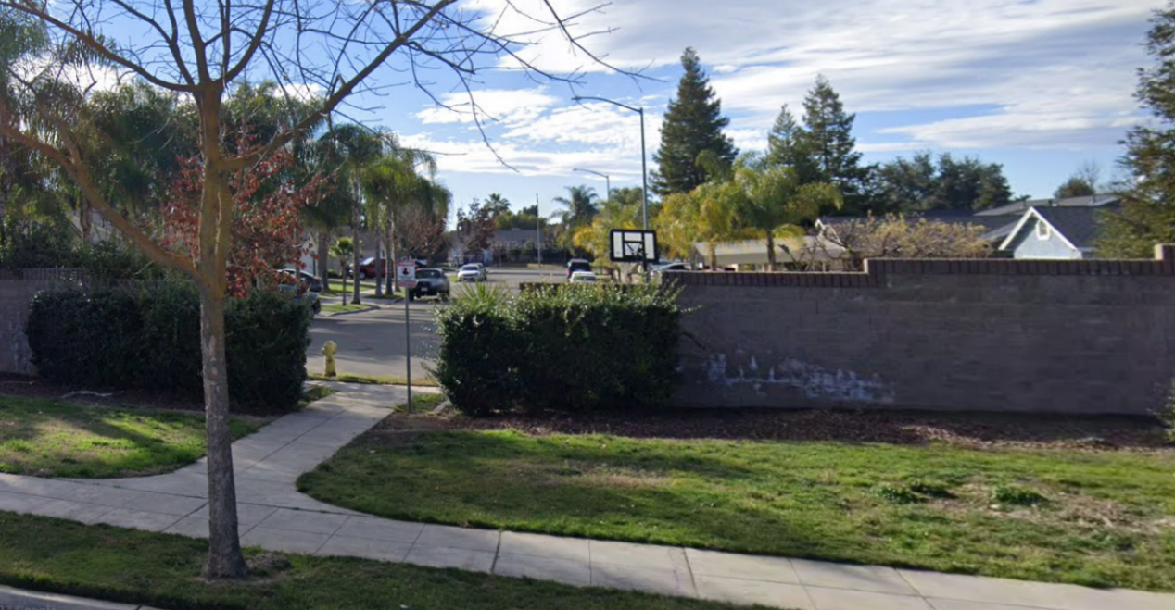
Landscaping along South Buttonwillow Avenue (Source: Google)

Roadway Design Guidance Opportunities
The Standard Specifications and Standard Plans are limited, and more clarification would be useful in certain cases. Some opportunities to improve the existing guidance include:
- Further guidance for bikeway facility design, including a greater range of facility types, the application of techniques such as buffers or vertical barriers that increase user comfort levels, and the appropriate facility type based on context factors such as street classification, traffic volume, or speed limit. Current guidance only includes standard bike lanes.
- Further guidance for pedestrian facilities, such as inclusion of landscape/physical (such as guardrail) buffers (aside from the limited cases requiring a masonry wall.) This would support General Plan goal LU 2.6H.
- Reference to Americans with Disabilities Act (ADA) requirements and PROWAG guidance.
- Guidance for prioritizing design features in constrained right-of-way cases by roadway type and context.
- Guidance for designing bikeways through intersections.
- Desired features and amenities for paved multi-use paths/trails.

