March 2024
Toole Design Group LLC
Appendix D: Pedestrian Needs Assessment and Bicycle Level of Traffic Stress Methodology

Pedestrian Needs Assessment

Defining Activity Areas
Pedestrian activity areas, which include parks, schools, and clusters of retail/service/community-oriented destinations, were identified across Reedley and form the basis of a detailed analysis of conditions for people walking and rolling.
Reedley’s Downtown District (slightly different from the “Downtown Core” used for this analysis, which extends south to include I Street) was designed with pedestrians in mind, and best practices from this area can be applied to all pedestrian activity areas across Reedley. Small block lengths of 400-500 feet allow pedestrians many opportunities to cross the roads. Sidewalks feature buffers with planter boxes and benches, most intersections have marked crosswalks, and the speed limit does not exceed 25 mph, even on collectors and arterials. These design conditions, along with national best practices for pedestrian safety and comfort (i.e., NACTO Urban Street Design Guide), informed the pedestrian analysis.
Pedestrian activity areas are comprised of a 1/3-mile buffer around major destinations; typically, people will walk 1/4 to 1/2 mile to access a destination, so 1/3 mile captures the average of that range. Since the Downtown Core is a district, while the other centers are point-based, its buffer was only 1/10 mile. Each activity area is listed below.
- Downtown Core – from 8th St to 13th St and I St to F St; key destinations include Pioneer Park, Reedley Parkway, City Hall, and Reedley Branch Library
- Reedley College and Retail Centers – centered around Manning Ave and Reed Ave; key destinations include Reedley College, Reedley High School, Reedley Middle College High School, and Riverwalk Retail Center, and the Reedley regional park & ride facility
- Northeast Reedley Retail Centers – centered around Manning Avenue from Columbia Avenue to Buttonwillow Avenue; key destinations include the Retail Plaza at Manning/11th, Reedley Shopping Center, Pocket Park (Myrtle Avenue)
- General Grant Middle School/Mueller Park; additional destinations include Reedley Community Center and Camacho Park
- Thomas Law Reed School/Citizens Park
- Immanuel High School/ Reedley Beach; additional destinations include Monument Hill Park and Cricket Hollow Park
- Reedley schools: Silas Bartsch School, Lincoln Elementary, Washington Elementary, and Jefferson Elementary
- Other locations: In addition to pedestrian activity areas, the perimeter roads of standalone parks were analyzed and include Reedley Sports Park and Columbia Park.

Pedestrian Needs Assessment
The following conditions were assessed for each pedestrian activity area:
- Sidewalk gaps
  - All gaps on arterials and collectors within pedestrian activity areas are considered a high priority.
  - Missing sidewalks outside of pedestrian priority areas may also be recommended for connectivity reasons.
- Landscape buffers
  - Presence of sidewalk buffer (buffer between sidewalk and traffic) and type of buffer (i.e., landscape, guardrail, bollards, etc.) on roads where speed limit exceeds 25 mph.
  - Buffers from traffic reinforce walkability; they may calm traffic and make conditions more comfortable for pedestrians on roads with higher speed limits (>25 mph).
- Maximum speed limits
  - Speed limits within pedestrian activity areas should ideally not exceed 25 mph.
  - Where speed limits do exceed 25 mph, additional separation between pedestrians and motor vehicles should be provided.
- Location and spacing of crossings
  - Crossings along arterials/collectors should be spaced every 400-500 feet within pedestrian activity areas (based on block spacing in Downtown Reedley) to support pedestrian use.
  - Crossings should exist at all school entrances; since schools are individual destinations with designated entrances, crossings every 400-500 feet are not necessary.
- Crossing type
  - Crosswalks should be marked at all signalized and stop-controlled intersections along streets with traffic volumes above 3,000 vehicles per day, posted speeds of 25 MPH or higher, and where there are two or more lanes of travel.
  - At schools, parks, plazas, senior centers, transit stops, hospitals, campuses, and major public buildings, marked crosswalks may be beneficial regardless of traffic conditions.
  - Crosswalks should contain high visibility (continental or ladder style) markings.
  - Presence of other crossing enhancements:
    - Curb extensions
    - Rectangular rapid flashing beacons (RRFBs)
    - HAWK signals
    - Pedestrian refuge island

Pedestrian Needs Assessment Findings
Sidewalks
Missing sidewalks are shown in yellow in Figure 2. In some instances, both sides of the street are missing sidewalks. Generally, sidewalks should be installed on both sides of the street where recommended, but in some places on the edge of City, such as the Manning Avenue/Zumwalt Avenue intersection, it is assumed that sidewalks would be installed only on the City side of the street.
This analysis focused on arterials and collectors in pedestrian priority areas, and as such, installing sidewalks in these locations are considered priority, but sidewalks should also be present along the perimeters of schools, regardless of functional classification. As of winter 2023, Jefferson Elementary is missing a sidewalk along Washington Avenue, though this sidewalk will be installed soon as part of an upcoming Safe Routes to School project.
Sidewalk Buffers
Sidewalk buffers may increase pedestrian safety and comfort, as well as calm traffic. In Reedley, buffers are typically planter boxes or landscaping. Ideally, sidewalk buffers should be present along all roads that exceed 25 mph within pedestrian activity areas. Since most high-speed roads in Reedley lack buffers, additional factors such as traffic volume, travel speeds, and overlapping pedestrian activity areas, can be used to prioritize were locations where installation of landscape buffers would be most beneficial. These locations are marked as dashed green lines in Figure 2.
Speed Limits
Maximum speed limits were assessed for all pedestrian activity areas. The Downtown Core has the lowest maximum speed limit of 30 mph (with a speed limit of 25 mph on most streets), but major roads throughout other pedestrian activity areas have speed limits of 35 mph and above. However, even speeds of 30 mph come with great risks for pedestrians: A study by the AAA Foundation for Traffic Safety (Tefft, 2011) found that the average risk of severe injury or fatality for pedestrians struck by a vehicle traveling 30 mph is 50 percent (Figure 1).
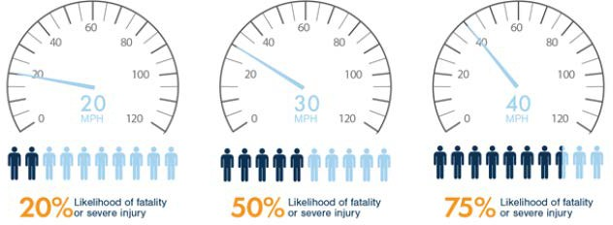
Figure 1: Risk of severe injury or fatality for pedestrians based on speed limit
Speed limits should not exceed 25 mph on roads adjacent to schools. Reedley does have 25-mph school zones, but the extents of these zones appear to be limited to school entrance zones. Twenty-five (25) mph school zones should extend along the perimeter of all schools in Reedley to encourage safe pedestrian access to schools. Many cities have reduced speed limits in school zones even further, such as in Sacramento, where 15 mph is now the speed limit in school zones.
While speed limit reductions are a cost-effective and efficient way to improve pedestrian safety and comfort and can be implemented without altering the right-of-way, signage and speed limit values alone do not fully address safety concerns. Additional design considerations, such as improved sidewalks and crossings and traffic calming measures, are needed to reduce crash rates and enhance pedestrian comfort levels.
Potential Crossing Locations
Designated crossings should be spaced a reasonable distance apart to encourage pedestrian activity. Using Reedley’s pedestrian-friendly Downtown District as a standard, designated crossings should ideally be spaced every 400-500 feet in pedestrian activity areas; however, greater spacing is acceptable in less densely developed areas. The level of residential and commercial activity varies in some of Reedley’s pedestrian activity areas and crossings are currently spaced far apart (¼ to ½-mile, such as along Dinuba Avenue in a portion of the Jefferson Elementary School activity area). Providing crossings every 400-500 feet may not make sense until redevelopment occurs, so more modest crossing distances were recommended in these areas.
Preliminary recommendations for existing crossing enhancements and recommended new crossings are shown in Figure 2. All crossing recommendations are made in conjunction with sidewalk recommendations. See Chapter 6 for the ultimate set of recommendations.

Additional Intersection Improvements
Beyond high visibility crosswalks, there are a variety of treatments that can improve crossing safety and comfort, pictured and described in greater detail in Chapter 6. These treatments include:
- Pedestrian refuge island: Protected space in the roadway median for pedestrians to pause while crossing a street
- Curb extensions that extend sidewalk into the street to minimize pedestrian crossing distance
- HAWK signals (also known as pedestrian hybrid beacons, or PHBs): Pedestrian-actuated three- light clusters (two red on top and one yellow below) located above the center of the roadway to stop traffic for safe crossing.
- Rectangular rapid flashing beacons (RRFBs): Pedestrian-actuated flashing yellow lights to alert vehicles to stop for pedestrians crossing
- Leading pedestrian interval (LPI): Programming traffic lights to allow pedestrians to cross 3-7 seconds before vehicles have the green light

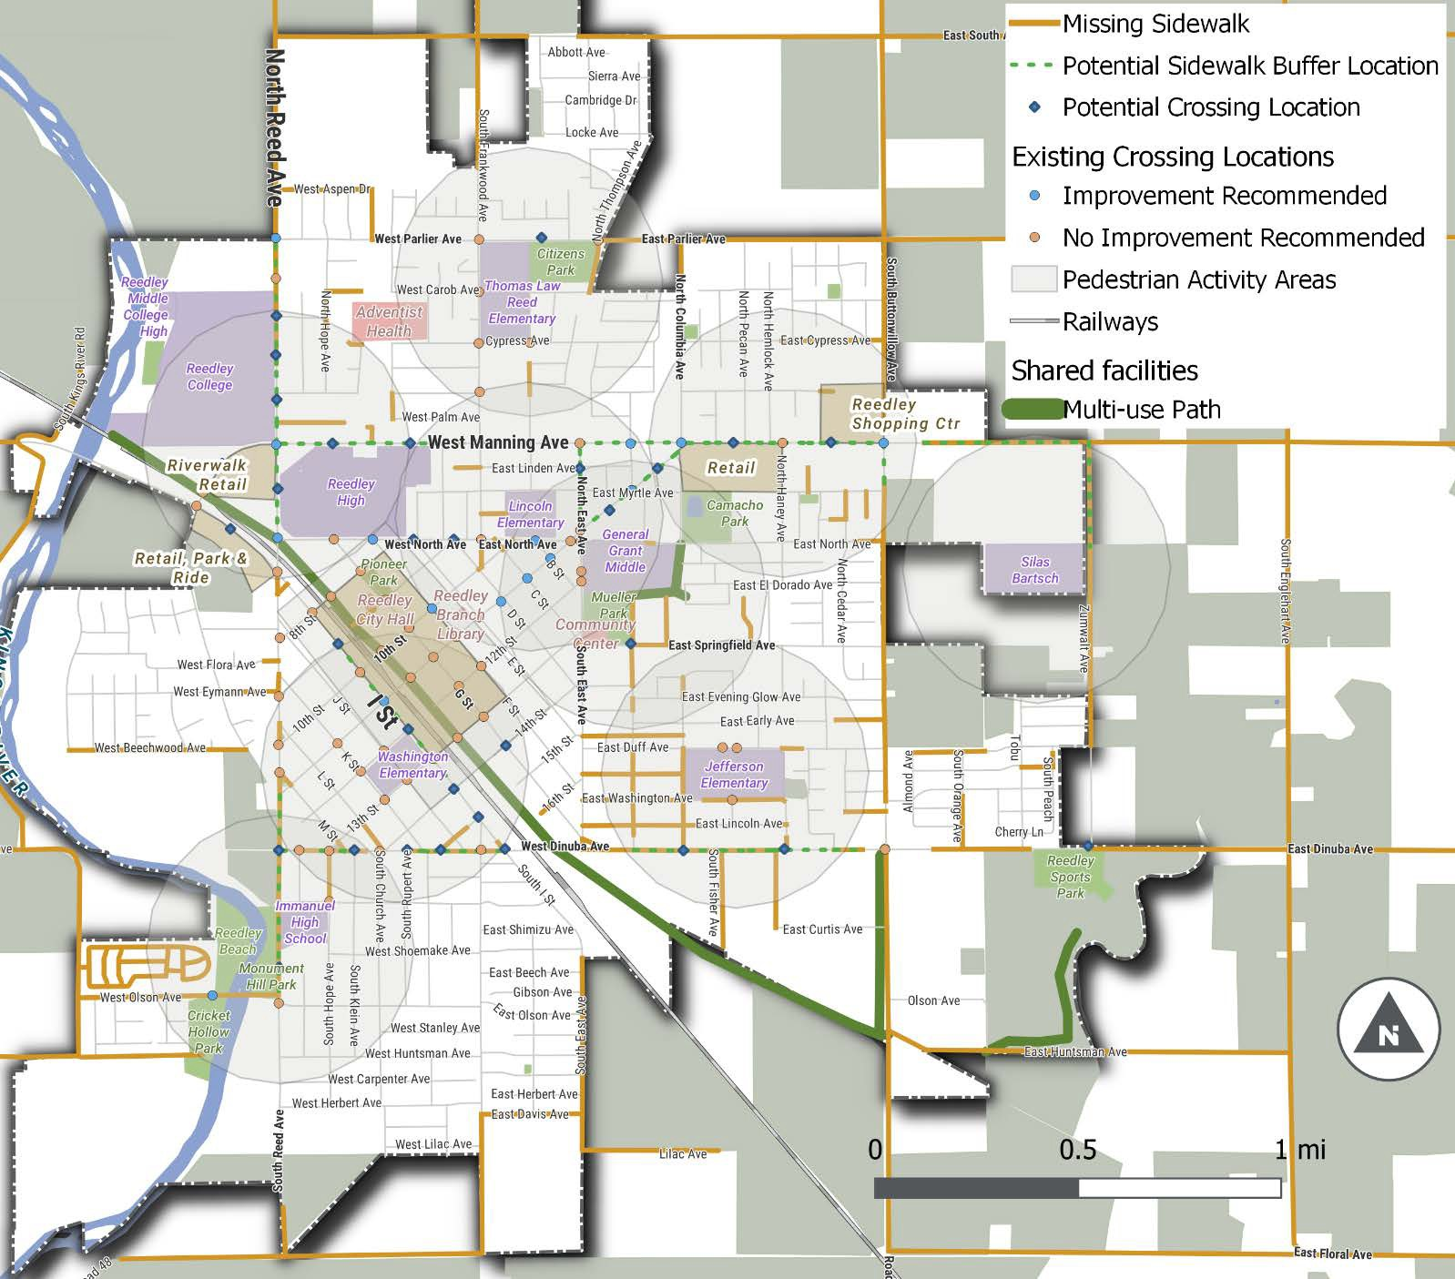
Figure 2: Pedestrian Needs Assessment Results

Bicycle Level of Traffic Stress Methodology
Bicycle level of traffic stress (LTS) is a tool for quantifying the comfort level experienced by most people bicycling along a roadway on a scale from 1 (least stress) to 4 (highest stress). The following inputs and street characteristics determine LTS scores for a road segment:
- Bicycle facility presence, type, and width
- Posted speed limit
- Number of travel lanes per direction
- Average daily traffic (ADT) volume
- Presence and width of on-street parking lanes
- Presence of a centerline
LTS analysis was applied to the entire network of streets and paved off-street paths in Reedley, including locations with and without dedicated bikeways. For the purposes of LTS analysis, only certain bikeways (i.e., bike lanes, shoulders, and trails) are considered to have dedicated bicycle facilities. Though bike routes help direct bicyclists to key destinations and raise awareness of their presence on the road to motorists, these routes are scored using the “mixed traffic” criteria as there is no physical separation between moving traffic and bicyclists and research indicates the presence of signs does not influence traffic stress. See Table 1 for criteria and LTS scores for segments with mixed traffic conditions, Table 2 for the criteria and LTS scores for segments with dedicated bicycle facilities and no on-street parking, and Table 3 for LTS scores for segments with dedicated bicycle facilities that are located adjacent to on-street parking.
Shared-use paths, such as the Reedley Parkway, and separated bike lanes, such as along Huntsman Ave, are considered low stress facility types and generate LTS 1, though high speeds and traffic volumes along the parallel road may affect user comfort levels along separated bike lanes. Road segments with on-street bike lanes generally receive scores of LTS 2 or 3, depending on the posted, traffic volume, whether on-street parking is permitted, and the parking utilization rate. Segments with higher traffic levels or parking generally create higher stress conditions for people bicycling.
It is important to note that LTS should be considered a basis for determining bicyclist comfort levels and that other factors influence the decision to ride a bicycle on a particular facility, including incidences of speeding and conflicts with turning movements associated with driveways and site access points.
Note on Data Sources: The LTS analysis used bikeway facility and posted speed limit data from the City of Reedley and traffic counts data from the Fresno Council of Governments. On-street parking and bikeway facility width data were collected from Google Earth and field observations. Manual edits and assumptions were applied to account for missing data and realistic use of facilities under existing conditions.

Table 1: LTS Criteria for Roads with Mixed Traffic
Number of traffic lanes | ADT | Posted speed limit
 |  | < 20 mph | 25 mph | 30 mph | 35 mph | 40 mph | 45 mph | 50+ mph
2-way street  (no centerline) | 0-750 | LTS 1 | LTS 1 | LTS 2 | LTS 2 | LTS 3 | LTS 3 | LTS 3
 | 751-1500 | LTS 1 | LTS 1 | LTS 2 | LTS 3 | LTS 3 | LTS 4 | LTS 4
 | 1501-3000 | LTS 2 | LTS 2 | LTS 3 | LTS 3 | LTS 4 | LTS 4 | LTS 4
 | 3000+ | LTS 3 | LTS 3 | LTS 4 | LTS 4 | LTS 4 | LTS 4 | LTS 4
1 thru lane per direction (1-way, 1-lane street or 2-way street with centerline) | 0-750 | LTS 1 | LTS 1 | LTS 2 | LTS 2 | LTS 3 | LTS 3 | LTS 3
 | 751-1500 | LTS 2 | LTS 2 | LTS 2 | LTS 3 | LTS 3 | LTS 4 | LTS 4
 | 1501-3000 | LTS 2 | LTS 3 | LTS 3 | LTS 4 | LTS 4 | LTS 4 | LTS 4
 | 3001-6000 | LTS 3 | LTS 3 | LTS 4 | LTS 4 | LTS 4 | LTS 4 | LTS 4
 | 6001-10000 | LTS 3 | LTS 4 | LTS 4 | LTS 4 | LTS 4 | LTS 4 | LTS 4
 | 10000+ | LTS 4 | LTS 4 | LTS 4 | LTS 4 | LTS 4 | LTS 4 | LTS 4
2 thru lanes per direction | 0-6000 | LTS 3 | LTS 3 | LTS 3 | LTS 3 | LTS 4 | LTS 4 | LTS 4
 | 6001-12000 | LTS 3 | LTS 3 | LTS 4 | LTS 4 | LTS 4 | LTS 4 | LTS 4
 | 12001+ | LTS 4 | LTS 4 | LTS 4 | LTS 4 | LTS 4 | LTS 4 | LTS 4
3+ thru lanes per direction | Any ADT | LTS 4 | LTS 4 | LTS 4 | LTS 4 | LTS 4 | LTS 4 | LTS 4

Table 2: LTS Criteria for Bike Lanes and Shoulders Not Adjacent to a Parking Lane
Number of lanes | Bike lane width (including buffers) | Posted Speed Limit
 |  | < 25 mph | 30 mph | 35 mph | 40 mph | 45 mph | 50+ mph
1 thru lane per direction, or with no centerline | 6+ ft | LTS 1 | LTS 1 | LTS 2 | LTS 3 | LTS 3 | LTS 3
 | 4 or 5 ft | LTS 2 | LTS 2 | LTS 2 | LTS 3 | LTS 3 | LTS 4
2 thru lanes per direction | 6+ ft | LTS 2 | LTS 2 | LTS 2 | LTS 3 | LTS 3 | LTS 3
 | 4 or 5 ft | LTS 2 | LTS 2 | LTS 3 | LTS 3 | LTS 4 | LTS 4
3+ lanes per direction | Any width | LTS 3 | LTS 3 | LTS 3 | LTS 4 | LTS 4 | LTS 4

Table 3: LTS Criteria for bike lanes alongside parking lanes
Number of traffic lanes | = Bike + parking Lane Width | Posted speed limit
 |  | 25 mph | 30 mph | 35 mph | 40+ mph
1 lane per direction | 14 ft | LTS 2 | LTS 2/3* | LTS 3 | LTS 4
 | 12-13 ft | LTS 2/3* | LTS 2/3* | LTS 3 | LTS 4
2 thru lanes per direction (2-way)  2-3 lanes per direction  (1-way) | 14 ft | LTS 2/3* | LTS 3 | LTS 4 | LTS 4
 | 12-13 ft | LTS 2/3* | LTS 3 | LTS 4 | LTS 4
Other multilane |  | LTS 3 | LTS 3 | LTS 4 | LTS 4

* Rating depends on parking turnover. Low turnover (i.e. residential) = LTS 2, high turnover (i.e. commercial or mixed use) = LTS 3

An assumption inherent in the LTS methodology is that protected bike lanes feature adequate physical separation between bicyclists and motorists and that the design ensures motorists do not encroach upon the bike lane.

